BS Program
Fall 2020

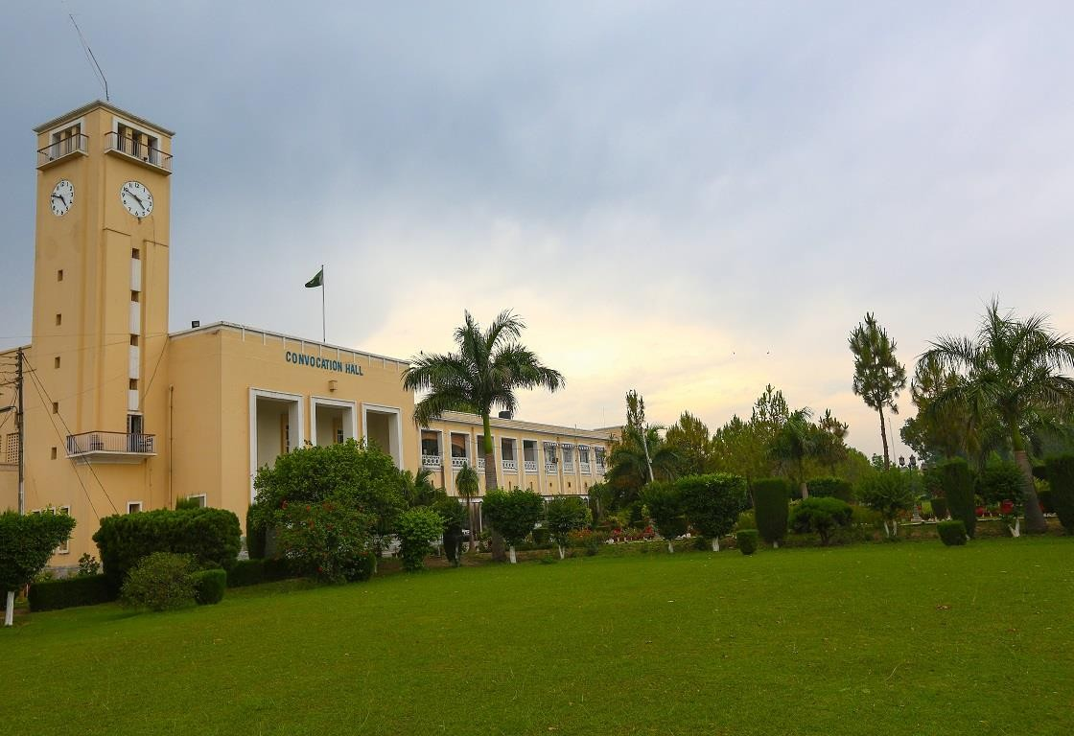

CONTENTS

Page No

1

INTRODUCTION
2

2

SCHOLARSHIPS OFFERED
3

3

BS ADMISSION NOTICE FALL 2020-21
4

4

HOW TO APPLY
7

5

SEAT BREAKUP
9

6

FEE STRUCTURE FOR BS PROGRAM 2020-21
11

2

INTRODUCTION

MISSION

The University of Peshawar, a future-oriented and unique institution is committed to achieving excellence in the undergraduate and graduate education, research and public service. The University provides superior and comprehensive education opportunities at the baccalaureate through doctoral and special professional educational levels. The university contributes to the advancement of society through research, creative activity, scholarly inquiry, and development of knowledge. The University preserves and promotes arts, benefits the nation's economy, serves the citizens through public programs and is dedicated to the production of quality human resource for the knowledge-driven development of the country.
VISION

To be a prominent public sector university in the South Asian region, recognized for its global perspective, diverse and supportive learning environment, having international reputation in research and creative discovery and emphasis on leadership development.
GOAL

To love and to serve the entire creation of the Creator.
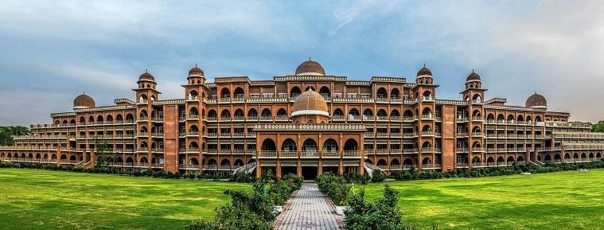

SCHOLARSHIPS OFFERED

3

Ehsas Scholarships

HEC-Needs Based Scholarships
- Prime Minister’s National Programme for provision of Laptops Scheme to Talented Students
- Petroleum Production Area Scholarship
- University of Peshawar Merit Cum Need Based Scholarship Program to students of All Departments/Institutes / Constituent Colleges
- University of Peshawar Merit Scholarships for B.A/B.Sc Position Holders
- University of Peshawar Brother / Sister 50% Concession in Tuition Fee
- Peshawar University Teachers Contribution & Endowment Fund for Needy and Deserving Students
- National Bank of Pakistan Student Loan Scheme
- Financial Assistance for Orphan & Disable Students
- MORA Scholarships all Districts
- Tribal Areas Political Scholarships
- Diya Pakistan Scholarship
- CM Endowment Fund Scholarship KPK
- Pakistan Baitulmal Scholarship
- The Punjab Educational Endowment Fund
- General Fee Concession
- Kohat Cement Factory Scholarship
- Al-Mujtaba Educational Trust Scholarship
- National Endowment Scholarship for Talent (NEST) only for M.Phil/PhD
- National Endowment Scholarship for Talent (NEST) only for Fine Arts students
- China Embassy Fund for needy & deserving students



UNIVERSITY OF PESHAWAR
4

REVISED ADMISSION NOTICE
BS DEGREE PROGRAMME (FALL-2020)

Admissions are open to BS (4 & 5 Years) degree programmes Session 2020-21 from 28.07.2020. The interested candidates shall submit Online Admission Application at the University Admission Portal http://admissions.uop.edu.pk.

A |  | FACULTY OF LIFE & ENVIRONMENTAL SCIENCES
S# | Programmes |  | Eligibility
1. | - BS Bio-Technology  - BS-Microbiology  - BS Botany  - BS Zoology |  | F.Sc (Pre-Medical) with at least 45% marks.
2. | - BS Chemistry  - BS Environmental Sciences  - BS Geology  - BS Geographical Information System / Remote Sensing (GIS/RS) |  | F.Sc (Pre-Medical/Pre-Engg) with at least 45% marks.
3. | - BS Disaster Preparedness & Management |  | F.A with Civics & Economics/F.Sc/Inter Science/DAE/D.Com with at least 45% marks.
4. | - BS Geography |  | Intermediate with at least 45% marks. 20 marks will be added to candidates with relevant subject.
5. | - Pharm-D (5-Year) |  | F.Sc (Pre-Medical) with at least 60% marks.
6. | - BS Urban & Regional Planning |  | F.Sc (Pre-Engg) with at least 45% marks.

B |  | FACULTY OF NUMERICAL & PHYSICAL SCIENCES
S# | Programme |  | Eligibility
1. | - BS Computer Science |  | F.Sc (Pre-Engg), FCS, General Science (with Computer) having at least 45% marks.
2. | - BS Electronics |  | F.Sc. with (Pre-Engg or DAE Electronics or Electrical) with at least 45% marks.
3. | - BS Mathematics |  | F.A/F.Sc/General Science (with Maths) having at least 45% marks.
4. | - BS Physics |  | F.Sc (Pre-Engg) with at least 45% marks.
5. | - BS Statistics |  | F.A/F.Sc/General Science with Maths or Statistics and having 45% marks.

5

C |  | FACULTY OF MANAGEMENT & INFORMATION SCIENCES
S# | Programmes |  | Eligibility
1. | - Bachelor of Business Administration (BBA) |  | Intermediate / D.Com with at least 45% marks. 30 marks will be added to General Science and  Humanities Groups.
2. | - BS Commerce |  | F.A/F.Sc or equivalent with at least 45% marks.
3. | - BS Journalism & Mass Communication |  | F.A/F.Sc with at least 45% marks.

D |  | FACULTY OF SOCIAL SCIENCES
S# | Programmes |  | Eligibility
1. | - BS Economics |  | F.A/F.Sc/General Science with at least 45% marks. 20 marks will be added to candidates with relevant  subject.
2. | ii. BS Education  iii. BS Political Science  iv. BS Psychology. |  | Intermediate with at least 45% marks. 20 marks will be added to candidates with relevant subject.
3. | v. BS Gender Studies vi. BS International Relations  vii. BS Sociology  viii. BS Social Work  ix. BS Regional Studies  x. BS Peace & Conflict Studies (IPCS) |  | Intermediate with at least 45% marks.
4. | xi. BS-LAW (5-Year) |  | F.A/F.Sc with at least 45% marks and at least qualifying marks in LAT.
5. | xii. BS Social Anthropology  xiii. BS Development Studies |  | F.A/F.Sc with at least 45% marks

E |  | FACULTY OF ARTS & HUMANITIES
S# | Programmes |  | Eligibility
1. | i. BS Archaeology  ii. BS Philosophy |  | F.A/F.Sc with at least 45% marks.
2. | iii. BS English & Applied Linguistics |  | Intermediate or equivalent with at least 45% marks
3. | iv. BS Art and Design |  | Intermediate or equivalent with at least 45% marks.
4. | v. BS History |  | Intermediate or equivalent with at least 45% marks. 20 marks will be added to candidates with relevant  subject.

F |  | FACULTY OF ISLAMIC & ORIENTAL STUDIES
S# | Programmes |  | Eligibility
1. | i. BS Urdu  ii. BS Islamiyat |  | F.A/F.Sc with at least 45% marks.
6

G |  | JINNAH COLLEGE FOR WOMEN
S# | Programmes |  | Eligibility
1. | i. BS Chemistry (For females only) |  | F.Sc with (Pre-Medical) with at least 60% (B Grade) for outsiders.
2. | ii. BS Economics (For females only) |  | F.A/F.Sc with at least 60% (B Grade) for outsiders.

H |  | COLLEGE OF HOME ECONOMICS
S# | Programmes |  | Eligibility
1. | i. BS Home Economics (For Females only)  Specialization Areas in :  - Art & Design  - Food & Nutrition Sciences  - Human Development & Family Studies  - Resource & Facility Management  - Textile & Clothing |  | F.A/F.Sc with at least 45% marks.

7

REVISED ADMISSION SCHEDULE
S.No | Event | Date | Day & Time | Venue
1. | Last date of submission of Admission Forms | 21.08.2020 | Friday  04:00 PM | Online  www.uop.edu.pk
2. | Hafiz-e-Quran Test | 24.08.2020 | Monday  09:00 AM to  01:00 PM | Convocation Hall, Main Administration Block, UOP
3. | Interview for seats reserved for disabled persons | 25.08.2020 | Tuesday  09:00 AM to  01:00 PM | Committee Room#3 adjacent to Convocation Hall
4. | Trials for Sports Seats | Detail schedule of Trials will be uploaded on University’s website on www.uop.edu.pk
5. | Display of Provisional Merit List | 01.09.2020 | Tuesday  10:00 AM | Online & concerned departments  www.uop.edu.pk
6. | Complaint(s) by the applicant(s), if any | 2nd & 3rd September, 2020 | Wednesday & Thursday  08:00 AM to  04:00 PM | Through Email  admissions@uop.edu.pk  to Directorate of Admissions
7. | Display of Final Merit List | 07.09.2020 | Monday  10:00 AM | Online & concerned departments  www.uop.edu.pk
8. | Admission from Merit List  Scrutiny of original documents & Remittance of Fee | 7,8,9 September, 2020 (3 days) | Monday to Wednesday  10:00 AM to 04:00 PM | Online & concerned departments  www.uop.edu.pk
9. | Admission from Waiting List | 10.09.2020 onwards | Thursday  10:00 AM | Online & concerned departments  www.uop.edu.pk
10. | Commencement of Classes | 15.09.2020 | Tuesday  08:00 AM | Online or Concerned Deptt: / Centre / Institute

HOW TO APPLY

- Visit http://admissions.uop.edu.pk
- Create Account by providing a valid email address
- Follow the step-wise instructions on the portal. For guidance please see the USER MANUAL for Online Admission Application at https://bit.ly/2ZrA18c6

MOST IMPORTANT INSTRUCTIONS

8

- The interested candidates shall submit Online Admission Applications at the university website : http://admissions.uop.edu.pk
- The candidates shall be required to send original bank slip and copy of printed online admission form to the Directorate of Admissions, Main Administration Block, University of Peshawar. Moreover, in view of COVID-19 and pursuance of Govt. directives issued from time to time, the above mentioned documents shall be sent through post/courier services before the deadline.
- All the candidates are instructed to apply for admission to respective discipline well in time without waiting for the last date in order to reduce the burden on online admission portal/website.
- Only those candidates would be declared eligible for provisional admission to BS having passed F.A/F.Sc DMC with required marks.
- Candidates who have passed intermediate exam in the current and preceding session i.e. 2019 & 2020 will be given 1st priority in admission, while the others will be given 2nd priority.
- Merit list of LLB (5-Years) will be based on the marks obtained in F.A/F.Sc primarily, however passing of Law Admission Test (LAT) in accordance with the decision of the Supreme Court of Pakistan dated 31st August, 2018 is compulsory. Moreover the merit list shall be provisional and admission shall be confirmed on passing of Law Admission Test, not later than the forthcoming LAT to be conducted by the HEC.
- No printed Prospectus or Admission Application Form will be issued. The candidates are required to apply online as per procedure mentioned above.
- Form once filled online and submitted after that no change whatsoever will be made. Moreover preferences as given on the form will not be changed.
- Candidates on the Final Merit List must appear for submission of fee and their documents on the given dates and should produce all the original documents along with three passport size photographs. If the candidate fails to do so, he / she will lose his / her chance of admission.
- All such admission will be offered provisionally, leading to obtain the status of regular admission, subject to the verification of all relevant documents and fulfilment of University of Peshawar admission policy / regulations.
- Candidates seeking admission in BS-LAW are required to submit Bar Council verified certificate and certificate from the office of the Registrar, Peshawar High Court for admission on reserved quota for Advocate & Judges respectively.
- All the departments are required to complete their admission from the Waiting Lists well before commencement of classes.
- No printed Prospectus or Admission Application Form will be issued. The candidates are required to apply online as per procedure mentioned above.
- All such admission will be offered provisionally, leading to obtain the status of regular admission, subject to the verification of all relevant documents and fulfilment of University of Peshawar admission policy / regulations.
- In case of providing wrong information or concealment of facts by the candidate his/her admissions will be cancelled and the same will be offered to next candidate on merit.
- The University reserves the right to withdraw any programme OR to modify the rules governing the programmes OR to make necessary amendments in the programmes OR courses of studies where deemed necessary. If the number of students admitted in a programme is less than 15, the admission in the said programme will be considered as cancelled.
- Incomplete application or received after due date shall not be accepted.
- For information, plz contact: 092-919221418 / 092-919216701-20 Extension: 3004 or visit http://admissions.uop.edu.pk or visit office of the Director Admissions, University of Peshawar in working days.

SEAT BREAKUP

9

FACULTY OF LIFE & ENVIRONMENTAL SCIENCES
S# | Department Name |  | Seats | S# | Department Name | Seats
1. |  | Biotechnology | 35 | 7. | Geology | 35
2. |  | Microbiology | 35 | 8. | Geographical & Information System / Remote Sensing  (GIS/RS) | 35
3. |  | Botany | 35 | 9. | Disaster Preparedness & Management (CDPM) | 35
4. |  | Zoology | 35 | 10. | Geography | 35
5. |  | Chemistry | 35 | 11. | Pharm-D | 40
6. |  | Environmental Sciences | 35 | 12. | Urban & Regional Planning (URP) | 35

FACULTY OF NUMERICAL & PHYSICAL SCIENCES
S# | Department Name | Seats | S# | Department Name | Seats
1. | Computer Science | 50 | 4. | Physics | 35
2. | Electronics | 35 | 5. | Statistics | 35
3. | Mathematics | 35

FACULTY OF MANAGEMENT & INFORMATION SCIENCES
S# | Department Name | Seats | S# | Department Name | Seats
1. | BBA | 50 | 2. | BS Commerce | 50
3. | Journalism & Mass  Communication | 35

FACULTY OF SOCIAL SCIENCES
S# | Department Name | Seats | S# | Department Name | Seats
1. | Economics | 50 | 7. | International Relations | 35
2. | Education | 35 | 8. | Sociology | 35
3. | Political Science | 35 | 9. | Social Work | 35
4. | Psychology | 35 | 10. | BS-Law (5-Year) | 35
5. | Gender Studies | 35 | 11. | Regional Studies | 35
6. | Development Studies | 35 | 12. | Social Anthropology | 35

FACULTY OF ARTS & HUMANITIES
S# | Department Name | Seats | S# | Department Name | Seats
1. | Archaeology | 39 | 3. | English & Applied Linguistics | 24
2. | Art & Design | 35 | 4. | Philosophy | 35
5. | History | 35

FACULTY OF ISLAMIC & ORIENTAL STUDIES
S# | Department Name | Seats | S# | Department Name | Seats
1. | Urdu | 35 | 2. | Islamiyat | 35

IMPORTANT NOTES ABOUT QUOTA SEATS

10

Quota Seats as per detail below are reserved in departments:

NAME OF QUOTA SEAT | DEPARTMENT | NO. OF  SEATS
Other Province (including AJK) | All Departments | 01
Minority | All Departments | 01
University Employee’s Children | All Departments | 01
Islamia College (CU) Employee’s  Children | All Departments | 01
Afghan with NADRA POR Card | All Departments | 01
Maldives Students | All Departments | 01
FATA / Tribal | All Departments | 01
FATA / Tribal | (for Geology & Pharmacy 02 Seats)
Disabled Person | All Departments | 01
Sports | All Departments | 01
HEC Sponsored Afghan Students | All Departments | 02
Northern Areas & Chitral | Geology Department | 01
Female | Electronics | 03
DAE (Electrical & Electronics) | Electronics | 02
Son / Daughter of Advocates | Law College | 05%
Son / Daughter of Judges of Superior  Courts | Law College | 01
Son / Daughter of Judges of Subordinate  Courts | Law College | 01

- For merged areas (FATA & FR) only those candidates are eligible who have passed intermediate exam from college located within that (Agency / FR) area as well as domicile of the (Agency/FR) area.
Regular & Self Support Seats

- Each program offers admission to regular, self-support and quota-based seats, depending upon the demand as determined by the number of applicants.
ELIGIBILITY FOR BS (4-YEARS) PROGRAMME

- Admission to BS (4-Years) Programme is open to candidates who have passed the qualifying examination of the BISE Peshawar or any other recognized Board, securing at least 45% marks in the aggregate.
- A candidate who has completed one professional stream will not be eligible for admission to any BS programme again.
- Applicant’s having 3rd Division or having less than 45% marks in aggregate are not eligible for all the disciplines irrespective of categories (Open – Reserved).

FEE STRUCTURE FOR BS PROGRAM 2020-21

11

Undergraduate – Regular/Open Merit Fee

S# | Program Name | 1st Semester/ Per Year onwards | 2nd Semester / Per year onwards | Mode
FACULTY OF ARTS & HUMANITIES
1 | BS Archaeology | 36500 | 35500 | Semester
2 | BS English & Applied Linguistics | 36500 | 35500 | Semester
3 | BS History | 36500 | 35500 | Semester
4 | BS Art & Design | 40800 | 39800 | Annual
5 | BS Philosophy | 36500 | 35500 | Semester

FACULTY OF ISLAMIC & ORIENTAL STUDIES
1 | BS Urdu | 29800 | 28800 | Semester
2 | BS Islamiyat | 29800 | 28800 | Semester

FACULTY OF LIFE & INFORMATION SCIENCES
1 | BS Botany | 36500 | 35500 | Semester
2 | BS Bio-Technology | 36500 | 35500 | Semester
3 | BS Chemistry | 37900 | 36900 | Semester
4 | BS Disaster Preparedness &  Management | 36500 | 35500 | Semester
5 | BS Environmental Sciences | 36500 | 35500 | Semester
6 | BS Geography | 36500 | 35500 | Semester
7 | BS GIS/RS | 36500 | 35500 | Semester
8 | BS Geology | 71400 | 70400 | Annual
9 | BS Microbiology | 36500 | 35500 | Semester
10 | Pharm-D (5-Years) | 74100 | 73100 | Annual
11 | BS Urban & Regional Planning | 36500 | 35500 | Semester
12 | BS Zoology | 36500 | 35500 | Semester

FACULTY OF MANAGEMENT AND INFORMATION SCIENCES
1 | BBA | 43200 | 42200 | Semester
2 | BS Commerce | 39200 | 38200 | Semester
3 | BS Journalism & Mass  Communication | 39200 | 38200 | Semester
4 | BS Home Economics | 36500 | 35500 | Semester

FACULTY OF PHYSICAL AND NUMERICAL SCIENCES
1 | BS Computer Science | 37900 | 36900 | Semester
2 | BS Electronics | 37900 | 36900 | Semester
3 | BS Mathematics | 36500 | 35500 | Semester
4 | BS Physics | 36500 | 35500 | Semester
5 | BS Statistics | 36500 | 35500 | Semester

12

FACULTY OF SOCIAL SCIENCES
1 | BS Economics | 37900 | 36900 | Semester
2 | BS Law (5-Year) | 43200 | 42200 | Semester
3 | BS Education | 37900 | 36900 | Semester
4 | BS International Relations | 35200 | 34200 | Semester
5 | BS Gender Studies | 35200 | 34200 | Semester
6 | BS Political Science | 36500 | 35500 | Semester
7 | BS Psychology | 36500 | 35500 | Semester
8 | BS Regional Studies | 36500 | 35500 | Semester
9 | BS Social Work | 35200 | 34200 | Semester
10 | BS Sociology | 36500 | 35500 | Semester
11 | BS Peace and Conflict Studies | 36500 | 35500 | Semester
12 | BS Development Studies | 37900 | 36900 | Semester
13 | BS Social Anthropology | 35200 | 34200 | Semester

Undergraduate – Self-Finance Fee

FACULTY OF ARTS & HUMANITIES
1 | BS Archaeology | 41700 | 40700 | Semester
2 | BS English & Applied Linguistics | 52700 | 51700 | Semester
3 | BS History | 41700 | 40700 | Semester
4 | BS Art & Design | 51000 | 50000 | Annual
5 | BS Philosophy | 41700 | 40700 | Semester

FACULTY OF ISLAMIC & ORIENTAL STUDIES
1 | BS Urdu | 41700 | 40700 | Semester
2 | BS Islamiyat | 41700 | 40700 | Semester

FACULTY OF LIFE & INFORMATION SCIENCES
1 | BS Botany | 52700 | 51700 | Semester
2 | BS Bio-Technology | 52700 | 51700 | Semester
3 | BS Chemistry | 52700 | 51700 | Semester
4 | BS Disaster Preparedness & Management | 52700 | 51700 | Semester
5 | BS Environmental Sciences | 52700 | 51700 | Semester
6 | BS Geography | 52700 | 51700 | Semester
7 | BS GIS/RS | 52700 | 51700 | Semester
8 | BS Geology | 103800 | 102800 | Annual
9 | BS Microbiology | 52700 | 51700 | Semester
10 | Pharm-D | 136800 | 135800 | Annual
11 | BS Urban & Regional Planning | 52700 | 51700 | Semester
12 | BS Zoology | 52700 | 51700 | Semester

13

FACULTY OF MANAGEMENT AND INFORMATION SCIENCES
1 | BBA | 52700 | 51700 | Semester
2 | BS Commerce | 52700 | 51700 | Semester
3 | BS Journalism & Mass Communication | 52700 | 51700 | Semester
4 | BS Home Economics | 52700 | 51700 | Semester

FACULTY OF PHYSICAL AND NUMERICAL SCIENCES
1 | BS Computer Science | 52700 | 51700 | Semester
2 | BS Electronics | 52700 | 51700 | Semester
3 | BS Mathematics | 52700 | 51700 | Semester
4 | BS Physics | 52700 | 51700 | Semester
5 | BS Statistics | 52700 | 51700 | Semester

FACULTY OF SOCIAL SCIENCES
1 | BS Economics | 52700 | 51700 | Semester
2 | LL.B (5-Year) | 52700 | 51700 | Semester
4 | BS Education | 41700 | 40700 | Semester
5 | BS International Relations | 41700 | 40700 | Semester
6 | BS Gender Studies | 41700 | 40700 | Semester
7 | BS Political Science | 41700 | 40700 | Semester
8 | BS Psychology | 41700 | 40700 | Semester
9 | BS Regional Studies | 41700 | 40700 | Semester
10 | BS Social Work | 41700 | 40700 | Semester
11 | BS Sociology | 41700 | 40700 | Semester
12 | BS Peace & Conflict Studies | 41700 | 40700 | Semester
13 | BS Development Studies | 41700 | 40700 | Semester
14 | BS Social Anthropology | 41700 | 40700 | Semester

NOTE
Admission Fee is Non-Refundable. In case of cancellation of admission, the remaining fee will be refunded as per approved University Policy.

COMMON FOR ALL PROGRAMMES

S# | Particular | Amount (Rs.) | Mode
1 | Retaining Fee (In case of Semester Freezing) | 1,600 | Semester
2 | Fee per Course (repeat cases) | 4,840 | Course

FEE FOR FIELD TRIP

Fee for the field trip, where applicable, will be deposited with the respective department as per following detail:
S# | Duration | Amount (Rs.) | Mode
1 | 1 – 3 days | 1500 | Per Field Trip
2 | More than 3 days | 5,000 | Per Field Trip
SECURITY (CAUTION MONEY)

14

Security (Caution Money) will be deposited with the respective department at the time of initial admission as per detail given below:
S# | Programme | Amount (Rs.) | Remarks
1 | BS | 5,000 | Refundable

HOSTEL FEE

S# | Particular | Amount (Rs.) | Mode
1 | Admission Fee -- 1st Year* /  Annual Charges -- 2nd Year onwards | 8000 | Annual
2 | Electric Charges | 8000 | Annual
3 | Room Rent | 10000 | Annual
4 | Generator + Maintenance Charges | 6000 | Annual
 | Total | 32000
NOTE

Hostel Admission Fee is Non-Refundable in case room is allotted. In case of cancellation of hostel admission after allotment of room, the remaining fee will be refunded as per approved University Policy.

FEE STRUCTURE FOR FOREIGN STUDENTS

(Amount in USD)
S# | Name of  Programme | Admission  Fee | Tuition  Fee | Misc. Fee | Total | Mode
1 | BS (Science) | 50 | 1303 | 100 | 1403 | Semester
2 | BS (Arts) | 50 | 1069 | 100 | 1169 | Semester

Dr. Zahid Gul
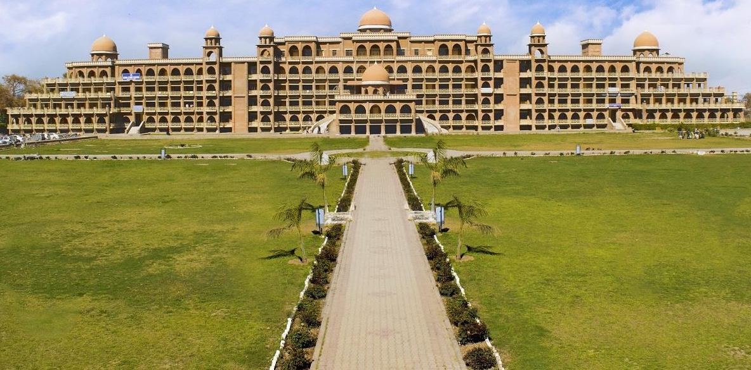
Director Admissions

